**Entry #______**

**Freedom Festival 2025**

**Pie Baking Contest**

Open to bakers of any age

MUST PRE-REGISTER BY FRIDAY, June 13 2025

Mail: Freedom Festival PO Box 316 Avilla, IN 46710

Email: [Avillafreedomfestival2014@gmail.com](mailto:Avillafreedomfestival2014@gmail.com)

Dropping off Red Mail box in Avilla Post Office lobby

Or completing on Website: https://freedomfestivalavilla.org/

June 19, 2025

Event begins at 6:30pm following the Kiddie King and Queen contest at the Main Stage. Pies may be dropped off at the Community Center building at Eley Park beginning at 4:30 pm on June 19th. Each entry will be assigned a number. Judges will not know who baked each item.

All crusts and fillings must be homemade. All Pies will be judged as one category and in the following three areas: Taste of filling, Taste of Crust and Presentation.

Baker’s Name: _________________________________Phone Number:­­­­­­­­­­­­­­­­_____________

Type of pie and description:________________________________________________

______________________________________________________________________

   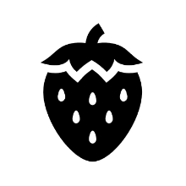

For questions, message us on FaceBook at “Avilla Freedom Festival” or call/text Lucinda at 260-349-8403.