Freedom Festival 2024
Pie Baking Contest
Open to bakers of any age

June 20, 2024
All Bakers must pre-register by Monday, June 17, 2024
All crusts and fillings must be homemade. All pies will be judged as one category.

Event begins at 6:30pm following the Kiddie King and Queen contest at the Main Stage. Pies may be dropped off at the Community Center building at Eley Park beginning at 4:30pm on June 20th. Each entry will be assigned a number. Judges will not know who baked each item.

Pies will be judged in three areas: Taste of Filling, Taste of Crust, Presentation

Entrants may pre-register by completing this form and mailing to:
Freedom Festival
PO Box 316
Avilla, IN 46710

Baker’s Name: __________________________________________________________

Type of pie and description:________________________________________________

______________________________________________________________________
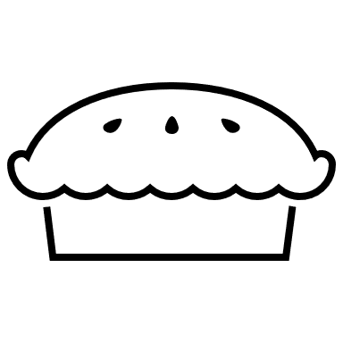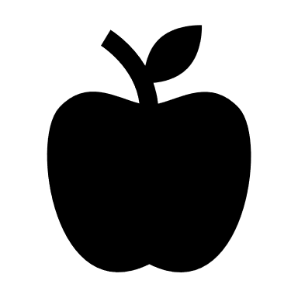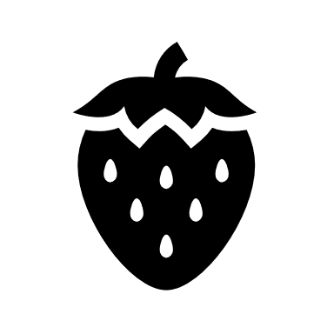

For questions, message us on FaceBook at “Avilla Freedom Festival” or call/text Lucinda at 260-349-8403. FreedomFestivalAvilla.org

